**Practical 1: Write python program to print values**

**Program:-**

print "hello!\n"+"Welcome to LDRP..\nMy name is Abc\nI am",20,"years old"

print "**********************************************************"

print 20,"+",20,"is",20+20

print "**********************************************************"

print 'apple'

print "**********************************************************"

print "mango"

print "**********************************************************"

print '''banana'''

print "**********************************************************"

print """grapes"""

print "**********************************************************"

print "pine""apple"

print "**********************************************************"

print "straw""""berry"""

print "**********************************************************"

print '''''''litchi'

**Output:-**

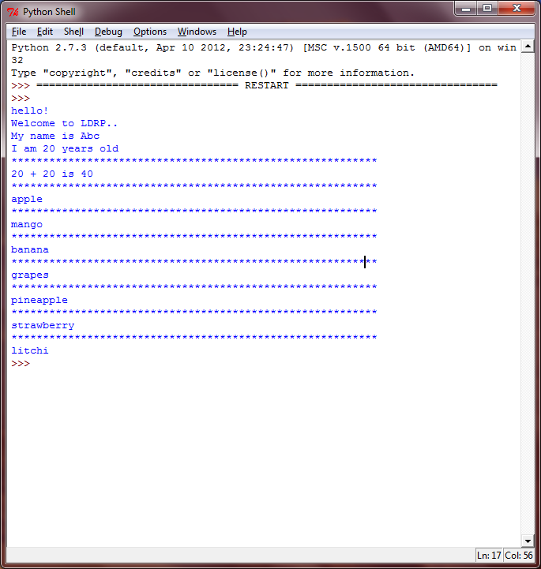

**Practical 2:- Write a program to learn the use of variables**

**(a). To print hello word using string variable**

**Program:-**

a="hello..!!"

print a,"\n"

print "Welcome to LDRP.."

**Output:-**

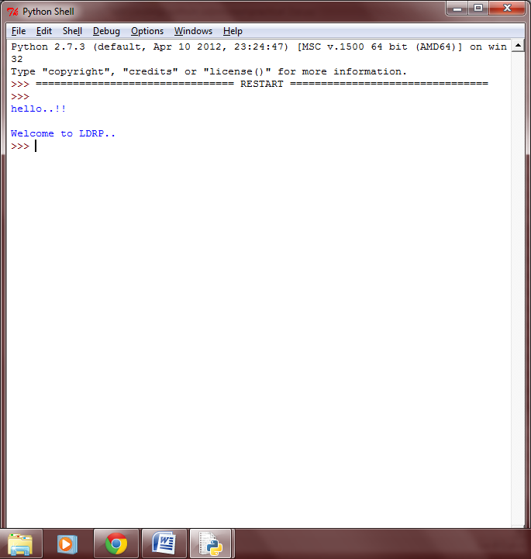

**(b). To do basic trim and slice on string**

**Program:-**

str1= "An apple a day keeps the doctor away."

print str1[:1]

print str1[1:]

print str1[1:2]

print str1[-1:]

print str1[:-1]

print str1[-6:-1]

print str1[22:-15]

print str1[22:-13]

print str1[22:-20]

print str1[::1]

print str1[1::]

print str1[1::2]

print str1[2::3]

print str1[1:9:2]

print str1[9:11:-1]

print str1[::-1]

print str1[-1::]

print str1[-1::-2]

print str1[8::-3]

print str1[-2::1]

print str1[-1:-5:-1]

**Output:-**

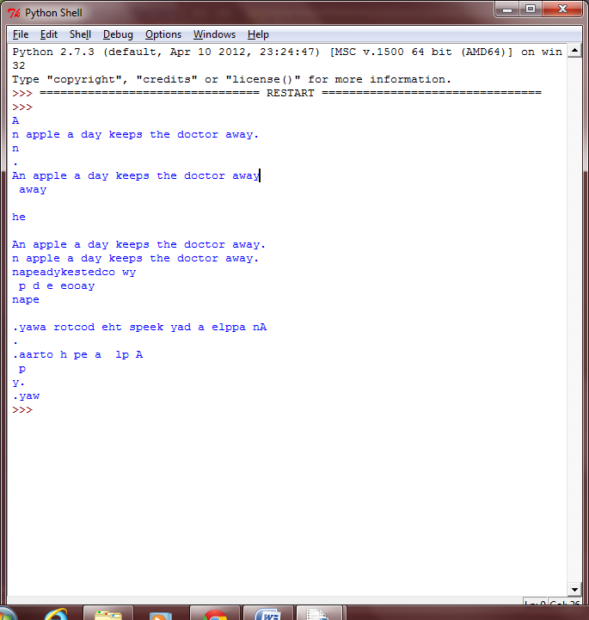

**(c). To use global variable**

**Program:-**

a=int(raw_input("enter no.:"))

sum=0

def fact(n):

if(n==0):

return 1

else:

return n*fact(n-1)

def series(m):

m=m+1

global sum

for i in range(1,m):

x= i*fact(i-1)/i

sum = sum + x

if(i<m):

print i,"!/",i,"+"

else:

print i,"!/",i

return sum

series(a)

print "=", sum

**Output:-**

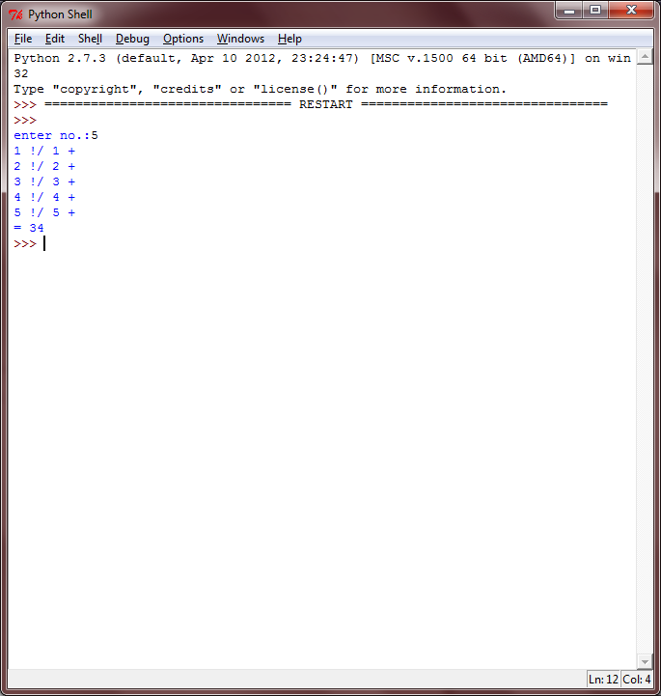

**(d). To let user enter some data in string and print hello user**

**Program:-**

name=raw_input("enter name:")

print "hello...!!!!!",name,"\nWelcome to LDRP...!!!!"

**Output:-**

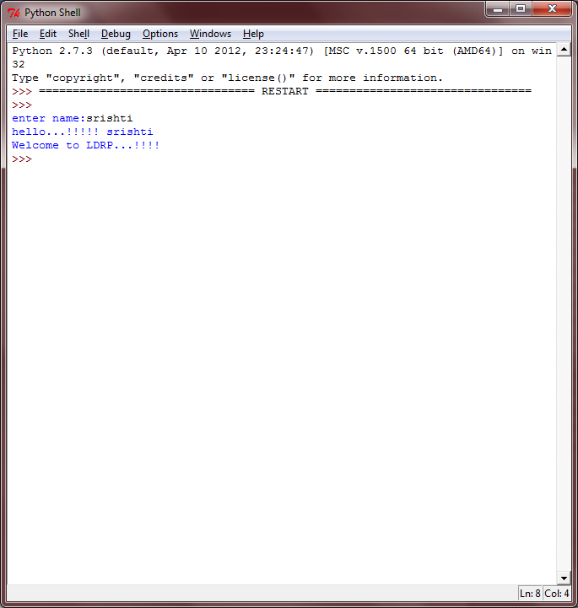

**Practical 3:- Write a program to use control flow system**

1. **To check whether a given number is even or not**

**Program:-**

number=int(raw_input("enter number:"))

if number%2==0:

print "the number is even"

else:

print "the number is odd"

**Output:-**

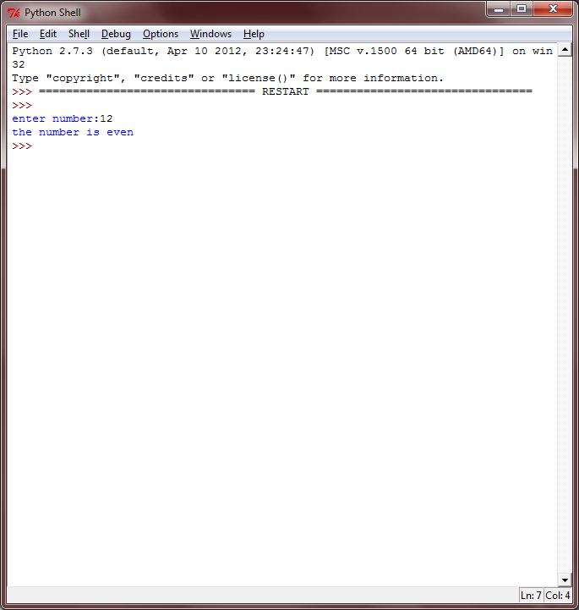

1. **To print grade of student using marks**

**Program:-**

marks=int(raw_input("enter marks on 100:" ))

if marks>=90:

print "The GRADE is A"

elif marks>=80 and marks<90:

print "The GRADE is B"

elif marks>=70 and marks<80:

print "The GRADE is C"

elif marks>=60 and marks<70:

print "The GRADE is D"

else:

print "The GRADE is F"

**Output:-**

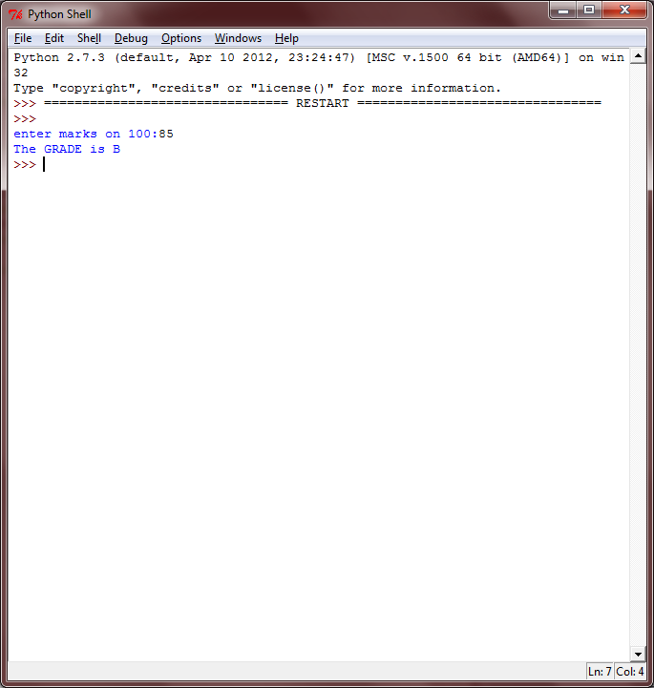

**Practical 4:- Write python program to store strings in list and then print them**

**Program:-**

a="aaa"

b="bbb"

c="ccc"

d="ddd"

e="eee"

l=[a,b,c,d,e]

print l[0]+" "+l[1]+" "+l[2]+" "+l[3]+" "+l[4]

**Output:-**

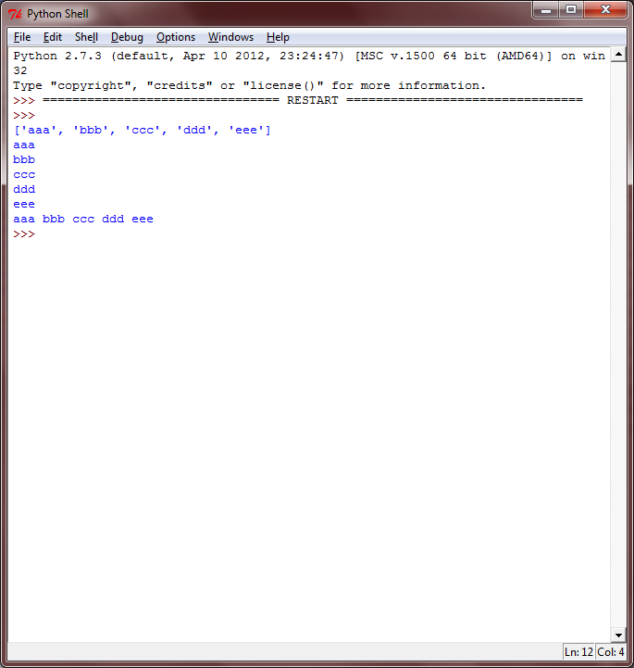

**Practical 5:- Write python program to implement the concept of operators**

**Program:-**

str1="congratulations"

str2="congratulations"

str3="on"

x=257

y=257

if str1==str2:

print str1,"and",str2,"are same."

else:

print str1,"and",str2,"are not same."

if str1==str3:

print str1,"and",str3,"are same."

else:

print str1,"and",str3,"are not same."

if "abc"=="abc":

print "abc and abc are the same."

else:

print "abc and abc are not the same."

if 255==255:

print "255 and 255 are same"

else:

print "255 and 255 are not same"

if 300 is 300:

print "300 and 300 are same"

else:

print "300 and 300 are not same"

if x is y:

print "257 is 257"

else:

print "257 is not 257"

print x is y

if str1 is str2:

print str1,"and",str2,"are same."

else:

print str1,"and",str2,"are not same."

if str1 is str3:

print str1,"and",str3,"are same."

else:

print str1,"and",str3,"are not same."

if str1 in str2:

print str1,"is present in",str2

else:

print str1,"is not present in",str2

if str3 in str1:

print str3,"is present in",str1

else:

print str3,"is not present in",str1

if str1 in str3:

print str1,"is present in",str3

else:

print str1,"is not present in",str3

**Output:-**

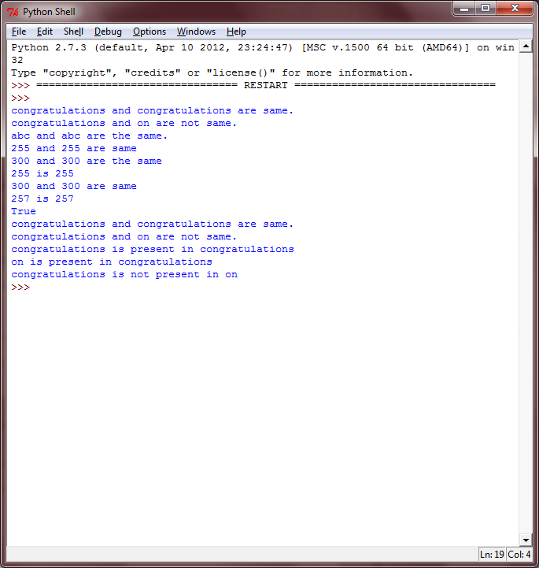

**Practical 6:- Write python program which covers all the methods (functions) of Set.**

**Program:-**

musicians=set(["aaa","bbb","ccc","ddd","eee"])

dancers=set(["sss","aaa","bbb","fff"])

singers=set(["aaa","bbb","ccc"])

musicians.add("ggg")

dancers.add("hhh")

print musicians

print dancers

print len(musicians)

print len(dancers)

print musicians.union(dancers)

print musicians.intersection(dancers)

print musicians.difference(dancers)

print musicians.symmetric_difference(dancers)

print musicians.issubset(singers)

print singers.issubset(musicians)

print "aaa" in musicians

print "fff" not in musicians

dancers.remove("bbb")

print dancers

singers.discard("aaa")

print singers

musicians.pop()

print musicians

dancers.clear()

print dancers

**Output:-**

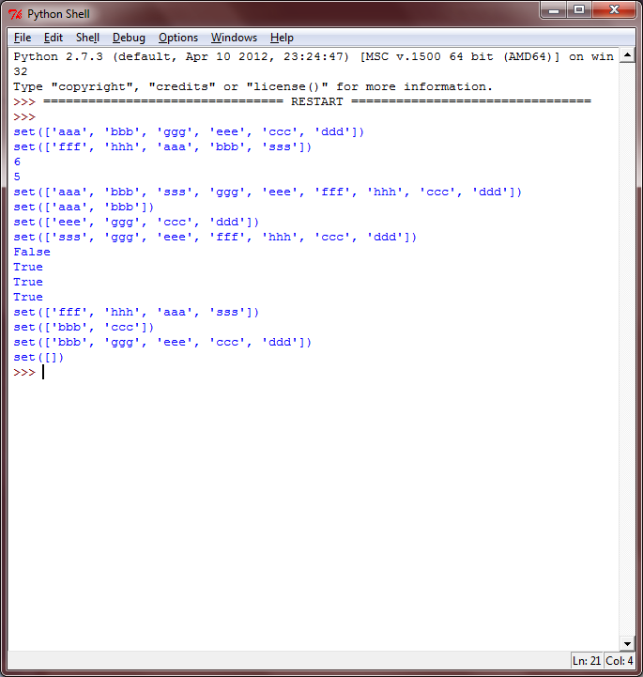

**Practical 7:-Write python program to print list of numbers using loop**

1. **To check whether the given no is prime or not**

**Program:-**

flag=0

for a in range(2,100):

for i in range(2,a):

if a%i==0:

flag=1

break

else:

flag=0

if flag==0:

print

**Output:-**

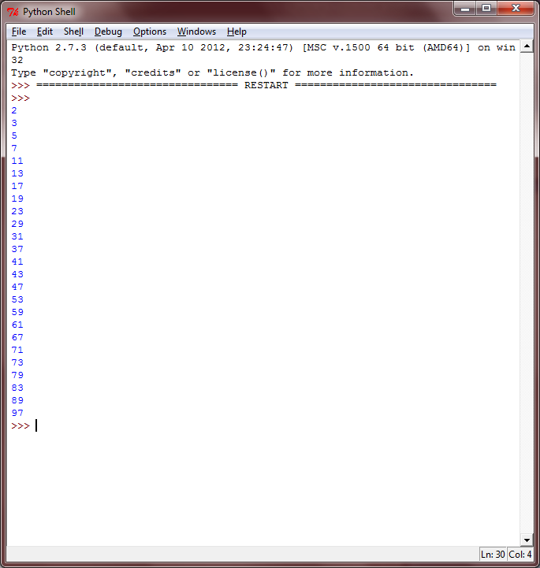

1. **To find factorial of given no.**

**Program:-**

num = int(input("Enter a number: "))

factorial = 1

if num < 0:

print("Sorry, factorial does not exist for negative numbers")

elif num == 0:

print("The factorial of 0 is 1")

else:

for i in range(1,num + 1):

factorial = factorial*i

print factorial

**Output:-**

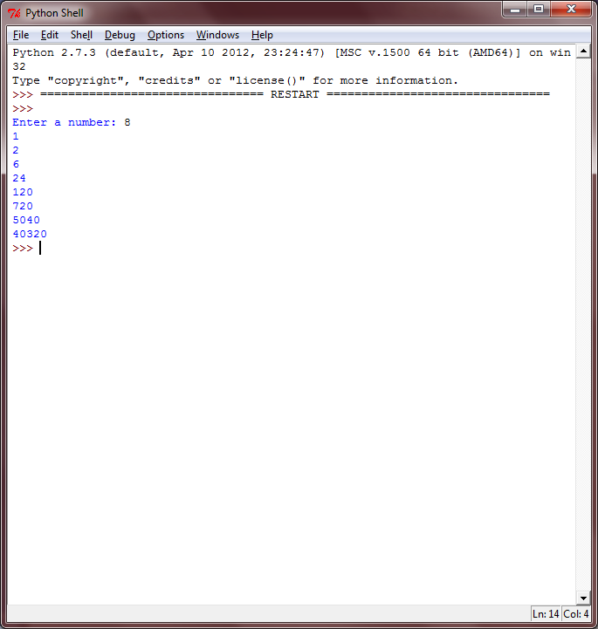

**Practical 8:-** **Write python program in which perform any operation using user defined function.**

1. **To find reverse of given no**

**Program:-**

num=int(raw_input("enter number:"))

rev=0

while(num!=0):

rem=num%10

rev=rev*10 + rem

num=num/10

a=rev

print rev

**Output:-**

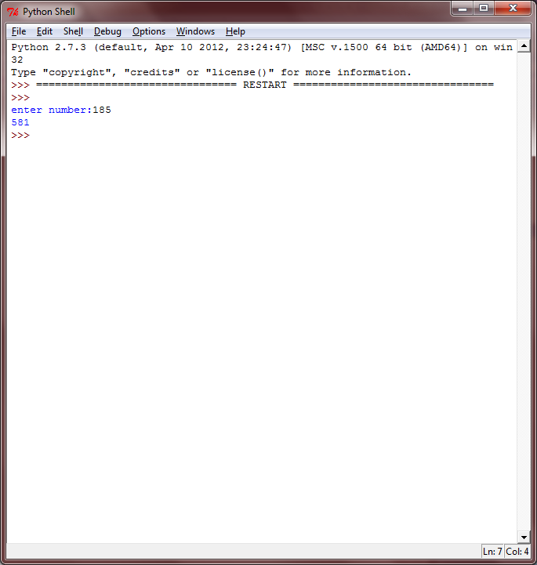

1. **To print Fibonacci series using recursion for N no.**

**Program:-**

def fibo(f1,f2,num):

print f1

f3=f1+f2

if(num!=0):

fibo(f2,f3,num-1)

no=int(raw_input("enter limit:"))

fibo(0,1,no)

**Output:-**

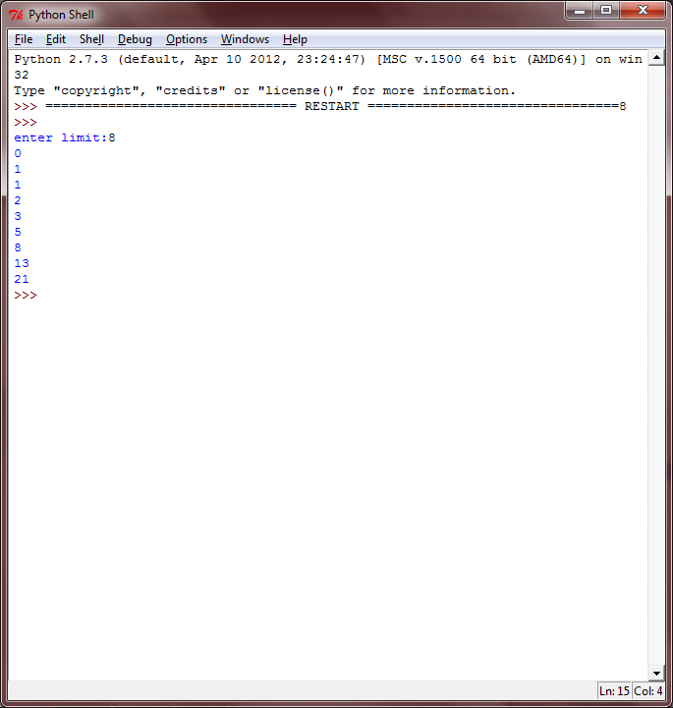

1. **To check whether the given no is Armstrong or not.**

**Program:-**

num = int(raw_input("enter num:"))

sum=0

temp=num

while(temp>0):

a=temp%10

sum=sum+a**3

temp=temp/10

if(sum==num):

print num,"is armstrong"

else:

print num,"is not armstrong"

**Output:-**

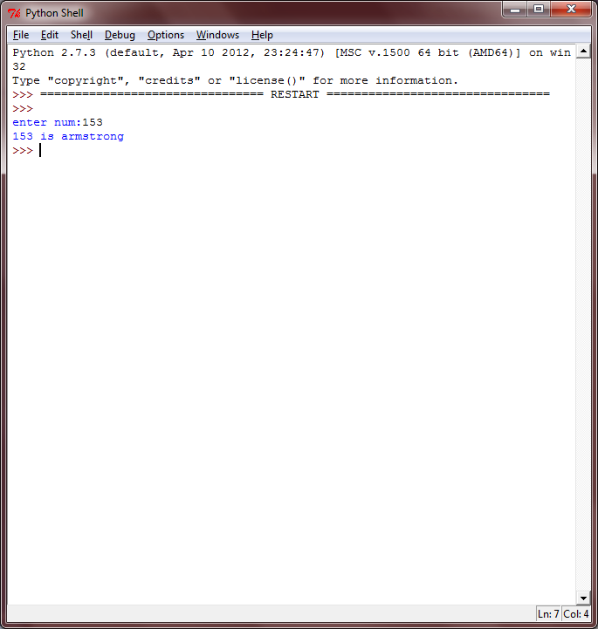

**Practical 9:-** **Write python program to check whether the given list is palindrome or not.**

**Program:-**

a=int(raw_input("enter element:"))

b=int(raw_input("enter element:"))

c=int(raw_input("enter element:"))

d=int(raw_input("enter element:"))

e=int(raw_input("enter element:"))

l=[a,b,c,d,e]

print l

print l[::-1]

if l==l[::-1]:

print "list is palindrome"

else:

print "list is not palindrome"

**Output:-**

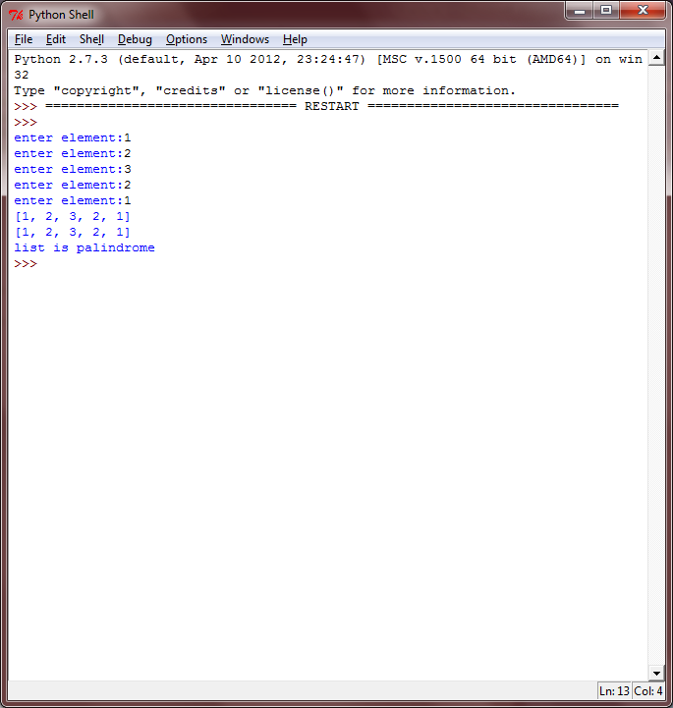

**Practical 10:-** **Write a program to find the prime number in a specific range using filter.**

**Program:-**

def prime(a):

count=2

flag=0

for count in range(2,a):

d=a%count

count=count+1

if(d==0):

flag=1

if(flag==0):

return a

print filter(prime,range(1,100))

**Output:-**

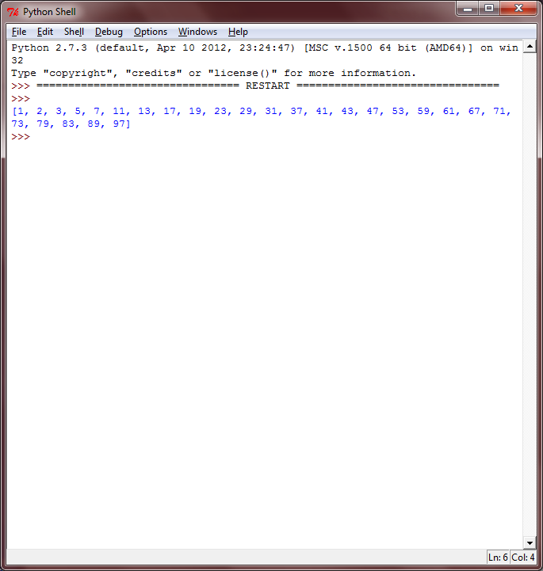

**Practical 11:-** **Write python program to make sum of particular range using reduce.**

**Program:-**

n1=int(raw_input("enter lower limit:"))

n2=int(raw_input("enter upper limit:"))

def red(x,y):

return x+y

print reduce(red,range(n1,n2+1)

**Output:-**

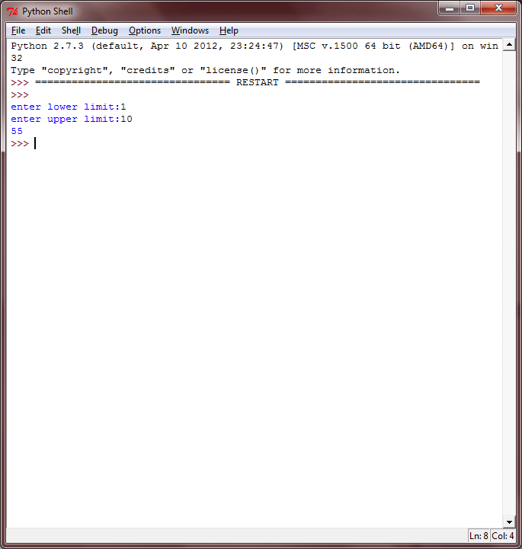

**Practical 12:-** **Write python program to find Armstrong number in a specific range using map.**

**Program:-**

sum=0

f=0

t=0

def arm(a):

global sum

global f

global t

if f==0:

t=a

sum=0

f=1

if (a > 0):

rem = a % 10

sum = sum + (rem * rem * rem)

a = a / 10

p = arm(a)

return p

else:

f=0

if (sum == t):

return sum

print filter(arm,range(1, 1000))

**Output:-**

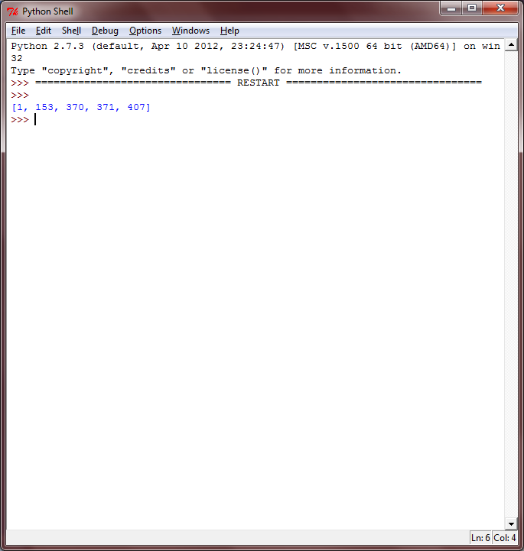

**Practical 13:-** **Read a text file in python and do following:**

**a. print no. of lines**

**b. print no. of statements**

**c. print no. of unique words**

**d. store each word with its occurrence in dictionary**

**File:-**

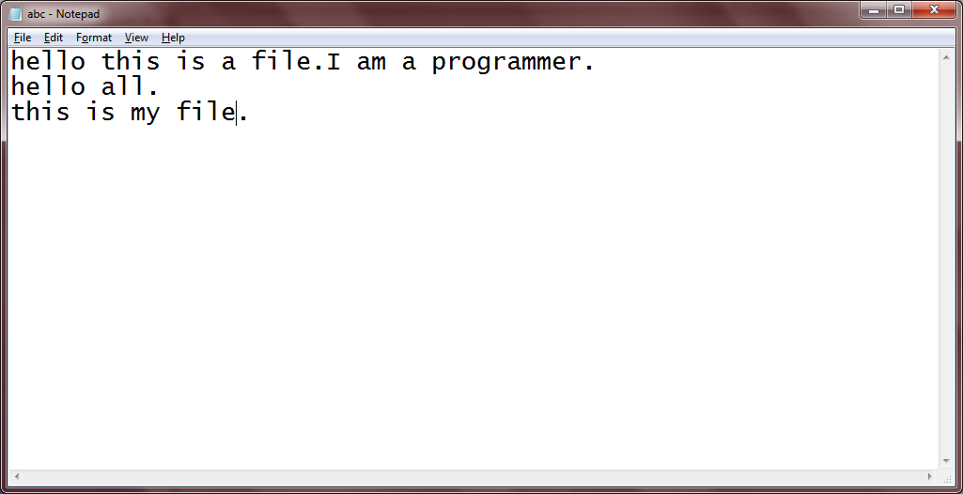

**Program:-**

i=open("abc.txt").read()

print "i).The number of lines::",i.count("\n")+1

print "ii).The number of statements::",i.count(".")

i=i.replace("\n",'')

i=i.replace(".",' ')

print i

items=i.split(' ')

print items

items.remove('')

print items

unique=0

dic={}

for new in items:

if new not in dic:

unique=unique+1

dic.update({new:items.count(new)})

print "iii).number of unique words is:",unique

print "iv).",dic

**Output:-**

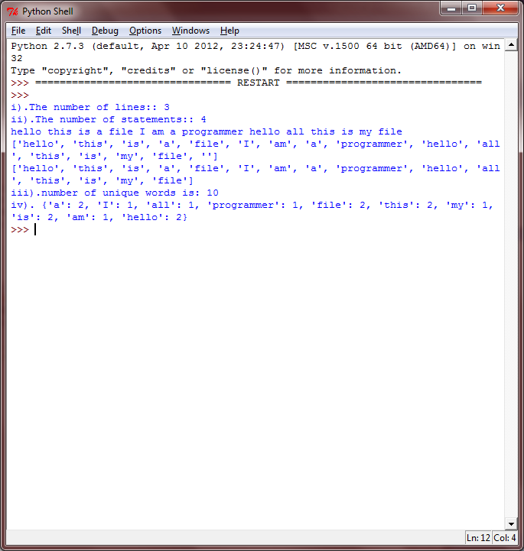

**Practical 14:-** **Flatten a nested list structure.**

**Example: if list1 = [1, [2, 3], [4, 5, [6, 7] ] ] then try to convert it in 1-dimensional [1, 2, 3, 4, 5, 6, 7].**

**Program:-**

def flat_list(l):

fl=[]

for item in l:

if (type(item)==list):

fl.extend(flat_list(item))

else:

fl.append(item)

return fl

print flat_list([1,[2, 3],[4, 5,[6, 7]]])

**Output:-**

